AVL Notes

An AVL tree (Adelson-Velsky and Landis) is a binary search tree with a height balance property and specific operations that rebalance the tree if necessary when a node is inserted or removed. Recall the height of the tree is the length of the longest path of distinct edges from the root to a leaf. A tree (or subtree) with just one node has height of 0. An AVL tree is height balanced if for any node, the heights of the node’s left and right subtrees differ by only 0 or 1. A node’s balance factor is the left subtree height minus the right subtree height (i.e., 1, 0, -1 in an AVL tree). For calculating balance factor, a non-existent (empty) left or right child’s subtree’s height is said to be -1.
Consider the two trees below.
D
D
1 – 0 = 1 2 – 1 = 1
L : 1 R : 0 L : 2 R : 1
E
C
E
C
0 – (-1) = 1 1 – (-1) = 2
L : 0 R: -1 L:1 R : -1
A
F
A

B
AVL tree
Not an AVL Tree

When inserting a new node, if the tree becomes unbalanced (balance factor +/- 2), we rebalance the tree through a rotation. Rotations will be applied to the nearest ancestor of the inserted node (the one whose balance factor is now +/-2). Let’s call this the ancestor node.

The AVL node class
The AVL node class extends off the Binary Node Class and can include 2 methods: a public balance factor method and private get height method. There are many ways to write an AVL node class, the following is an example.
public class AVLNode extends BinaryNode {

public AVLNode(Comparable x)
{
super(x);
}

public int balanceFactor()
{
return getHeight(left())-getHeight(right());
}

private int getHeight(BinaryNode k)
{
if(k == null)
return -1;
return 1 + Math.max(getHeight(k.left()),
getHeight(k.right()));
}
}
The get height method is a private method that finds the height for the Binary Node, it could have been easily included in the BinaryNode class as a public method. Here, the AVL class chooses to use it as a helper method rather than assuming the BinaryNode class contains it. The balance factor is a method rather than an instance variable, because it is always in a state of flux based on where the node is located in the tree.

Insertion Cases
Case #1: If the inserted node was added to the left subtree of the ancestor’s (in this case C) left child, then the outside-outside rotation would be a left – left rotation that rotates to the right. Be sure to maintain BST ordering
Case #2: If the inserted node was added to the right subtree of ancestor’s (in this case A) right child, then the outside – outside rotation would be a right – right rotation that rotates to the left. Case #2 is a mirror version of Case #1.
Case 1
B
C
2 2 – 1 = 0
C
A
B
1 Left-Left Rot. 0 0
A
0
Left unbalanced tree Balance Tree
Case #3: If inserted node was added to right subtree of the ancestor’s left child, you perform a Left-Right rotation (LR). This is a two step rotation that is a combination of rotating left and rotating right
Case 1
B
C
C
2 2 0
C
A
B
A
-1 Left Rotation 1 0 0
Right Rotation
A
B
0 0
Tree is imbalanced After Left Rotation After Right Rotation, Tree is balanced
Case #4: If inserted node was added to left subtree of the ancestor’s right child, perform a Right-Left rotation (RL). this is a two-step rotation that is a combination of rotating right and rotating left. Case #4 is a mirror of Case #3.

An AVL Example
Insert the following into an AVL tree: 14, 17, 11, 7, 48, 4, 13. Everything is fine up until the 4 is added
0 1
14
14

1 -1 2 -1
17
11
17
11

0 0 1 LL 0
48
7
48
7

Before 4 is added 0 After 4 has been added, Tree is imbalanced
4

When the 4 Node is added, the 11 Node ancestor exceeds the balance factor at 2. So a LL rotation must occur on the 11 Node.
14
0

0 -1
17
7

0 0 0
48
11
4

After LL rotation is done on node 11

The value 13 is added with no consequence, but when the value 12 is added to the tree, the tree needs to perform a RL double rotation to balance the tree.
2 2
14
14

-2 -1 -2 -1
7
17
17
7

0 -2 0 0 -2 RR 0
11
48
4
48
11
4

1 -1
12
13

0 rotate right 0
13
12

After 12 is added, tree imbalanced After First Right Rotation of RL Rotation
1
14

-1 -1
17
7

0 0 0
12
48
4

0 0 After RL Rotation is complete, notice how all heights are fixed.
11
13

Adding in the value 8 unbalances the tree as well at Node 7, and will require a RL Rotation.
2 -2
14
14

-2 -1 -2 -1
7
17
17
7

0 1 0 0 -1 0
4
11
48
12
48
4

-1 0 0 -1
8
12
11
13

0 0
13
8

Before the Rotate Right of an RL After the rotate right, before the Rotate Left or RL
Sometimes an AVL must move a branch onto another branch because its parent is becoming an ancestor. In this case the demoted ancestor will become the parent of the child branch. Node 8 will unhook from node 11 as node 11 is made an ancestor and will connect to node 7 as it becomes the demoted ancestor.
1
14

0 -1
17
11

0 -1 0
48
12
7

0 0 0
13
8
4

Now try to make a new AVL tree using the following numbers

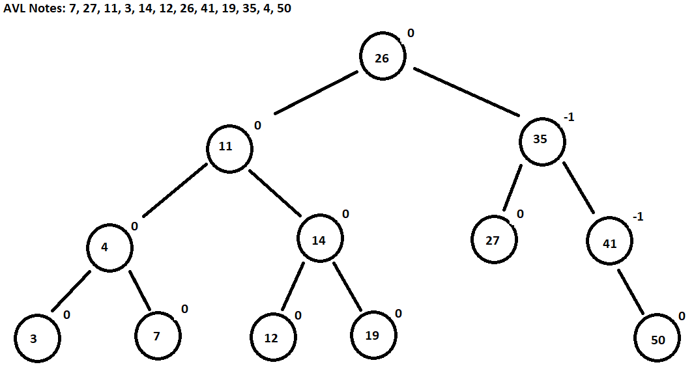

Coding the AVL
Algorithm for a single rotation, assume x and z are the nodes the program wants to move. t is the subtree with the subscript distinguishing each tree.
parent
X
Rotate Left
Z
t_{a}

t_{c}
t_{b}

Algorithm for Single Rotation Left
- Change X’s parent to point Z
- Change X’s right link to point Z’s left link
- Change Z’s left link to point X

parent

z

t_{c}
X

t_{b}
t_{a}

Algorithm for a double rotation, assuming that x, y, and z are the nodes you want to move. t is the subtree with the subscript distinguishing each tree. In this case, we will do a RL rotation
parent

Do Left rotation last
x

Do right rotation first
t_{a}
z

y
t_{d}

t_{c}
t_{b}

Algorithm for Right Left Rotation
- Change Y’s right link to point to Z
- Change Z’s left link to point to Y’s right link
- Change X’s parent to point to Y
- Change X’s right link to point to Y’s left link
- Change Y’s left link to point to X

parent

y

z
x

t_{c}
t_{b}
t_{a}
t_{d}

Deleting from an AVL
When deleting from an AVL, the student deletes like they are deleting from a naive binary tree. The delete node is swapped with its inorder successor until the node is a leaf or a one child node. Once there, the programmer performs a deletion. However, the AVL must check to see if a rebalance is necessary.
1 1
84
84

1 1 2 -1
89
61
89
61

1 0 0 1 0
93
21
93
63
21

0 0
12
12
Before removing 63 After removing 63, perform a LL on 61
0
84

0 -1
89
21

0 0 0
61
93
12

Red Black Trees vs AVL Trees
So what’s the difference between using a red black tree and an AVL? The core difference is that a red black tree will tolerate a certain amount of unbalanced-ness in the tree but still maintain a O(log n) running time. The AVL tree does not do this, and is stricter. This means that a red black tree will not call rotate until it absolutely has to, whereas an AVL tree is going to call a rotate more. The AVL has a faster retrieval time because of its strict balancing. Red Black trees have faster insertion and removal operations because of its fewer rotations. AVL uses more storage because it is holding heights on each node because it uses an integer whereas red black uses 1 bit for its red/black color. Finally, red black trees are used in most programming techniques such as map, multipmap, and multisets while AVL are used in databases for its faster retrieval time.

